

Software Project

**Alice Corry**

**Your student number is N00211635**

Software Project

Produce a software solution for a business case study or a non-commercial client you identify.

Year 2 2022-23

DL836 BSc (Hons) in Creative Computing

Link to resources created as part of the project.

| GitHub | <https://github.com/y2-SW-project/swproject23-ac-png.git> |
| --- | --- |
| Miro | <https://miro.com/app/board/uXjVPsp37ug=/?share_link_id=281630697980> |
| Figma (Project) | <https://www.figma.com/files/project/81876427/Software-Project?fuid=1026808025755109748> |
| Video | Link to your video file (MS Stream, YouTube) |

Table of Contents

1. Introduction

2. Business Concept

2.1. Business Idea

2.2. Business Model

2.3. Market Research

2.4. Marketing/Advertising

2.5. Suppliers

2.6. Competitors

2.7. Employees

2.8. Environmental Impact

3. Requirements

3.1. Introduction

3.2. Requirements gathering

3.2.1. Similar applications

3.2.2. Interviews

3.3. Requirements modelling

3.3.1. Functional requirements

3.3.2. Non-functional requirements

3.3.3. Use Case Diagrams

3.4. Feasibility

4. Web Application Design

4.1. Layout

4.2. Interaction

4.3. Colour schemes

4.4. Font choices

4.5. Wireframes

5. Database Design

5.1. Description

5.2. Business Reporting Requirements

5.3. Textual Representation of Dataset

5.4. Business Rules

5.5. Entity Relationship Diagram

5.6. Tables

5.7. Database Dictionary

6. System Design/ Architecture Overview

6.1. Introduction

6.2. Model View Controller

6.3. User Authentication

6.4. Routing

6.5. Templating

7. Testing

7.2.1. Login/Registration

7.2.2. Navigation

7.2.3. Calculation

7.2.4. CRUD

7.2.5. Discussion of Functional Testing Results

8. Project Management

8.1. Introduction

8.2. Project Phases

8.2.1. Requirements

8.2.2. Design

8.2.3. Implementation

8.2.4. Testing

8.3. SCRUM Methodology (optional)

8.4. Project Management Tools

8.4.1. GitHub Project

8.4.2. GitHub

9. Reflection

9.1. Your views on project

9.2. How could the project be developed further?

9.3. Assessment of your learning.

9.4. Completing a large software development project

9.5. Technical skills

9.6. Further competencies and skills

10. References

# 

# Introduction

**Overall aim**

Using what we have learnt over the last two years, we must build a Laravel web application with CRUD (Create, Read, Update and Delete) functionality.

**Technologies**

I connected to the server and database using PHP.

I created and organized my database using MySQL.

Bootstrap is the CSS framework I used to style my website.

I styled the website using CSS.

I built the website using HTML.

**Tools**

For my database, I used phpMyAdmin to design a sample structure.

I used this to do research and come up with ideas, Miro.

To wireframe my website, I used Figma.

For my project, I used TablePlus as my database tool.

**Project management**

I frequently saved my code on GitHub and added comments so my lecturers would know what I was working on.

# Business Concept

## Business Idea

DietOnline is an online grocery store that sells specialised food based on different diets. We sell dairy-free, meat-free, gluten-free and other products in ready-to-go packages. Our food will substitute traditional food but still provide the same great taste and nutrition.

We only want to provide nutritional, ready-to-go food, so our food is over half the price of regular shops. We sell everything from bread to sausage and offer services linked to specialised food.

Some of the products and services are;

* Meat-free products (sausages, rashers, burgers, etc.)
* Dairy-free products (milk, butter, cheese, etc.)
* Gluten-free products (bread, biscuits, etc.)
* Products for other diets (low fat, low cholesterol, etc.)
* Recipes for specific diets
* Guides and advice for each diet

## Business Model

Our business model is through service charges for manufacturers, regular customer purchases and any donations we get.

## Market Research

Their customers are individuals and families of all ages on specialised diets and those thinking of going on one.

The customers in this target market are interested in buying healthy, cheap and sustainable for their diets. They sell affordable meals in recyclable packaging with easy-to-read ingredients and instructions to appeal to their target market.

## Marketing/Advertising

We will market on social media and in newspapers, buses and bus stops.

We will also reach out to various dietary groups and influencers to spread the message of our food.

## Suppliers

Our suppliers would be food manufacturers who share our value in diet-friendly and sustainable food. Before officially contracting, we will do a background check on all suppliers to ensure they use proper practices.

We will also offer a way to sign up as a supplier via our website, although they must come in for a meeting later.

## Competitors

| **Product / Service** | **Strengths** | **Weaknesses** |
| --- | --- | --- |
| Aldi (Plant Menu and Free-from Ranges) | * Cheap * Easy-to-make | * No online shopping option * Scattered around the shop and website |
| The Happy Pear | * All food vegan * Easy-to-make * Website has recipes and guides | * No online shopping option * In very few shops * Only one shop in all of Ireland (Greystones) |

## 

## Employees

Our business operates as a warehouse-like business. When customers order food from our website, our warehouse employees go through our various warehouses with an iPad and pick out all the food.

When the food is picked out at the warehouse, one of our truck drivers will drive to your location and deliver the food to you.

## Environmental Impact

Since most of our target market is vegans, we ensured that our products were packed in all recyclable materials.

We also do our best to ensure that all our manufacturers use sustainable means when making and preparing food.

# Requirements

## Introduction

The requirements phase allows developers to determine what the program should be able to do.

Instead of the developer explaining what is necessary, learning what the users would like the application to do is essential.

## Requirements gathering

## Similar applications

1. [**Kroger**](https://www.kroger.com/)

**Description**

An American online food store sells organic and plant-based foods that are good for the environment and a healthy lifestyle.

**Advantages**

* The website's UI is excellent overall; it is easy to understand and doesn't require a lot of colours.
* The single-product page seems to have a lot of content, including nutritional information, reviews and similar products.

**Disadvantages**

* It's difficult to tell what to click on the navigation bar at the top of the page to access the various parts of the site.
* There seems to be a variation in prices; while some items are quite cheap and have deals, the majority appear to be very pricey.

**Screenshots**

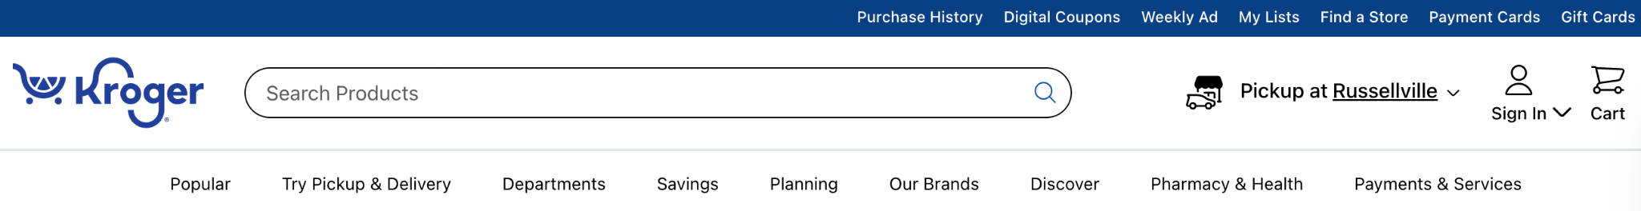

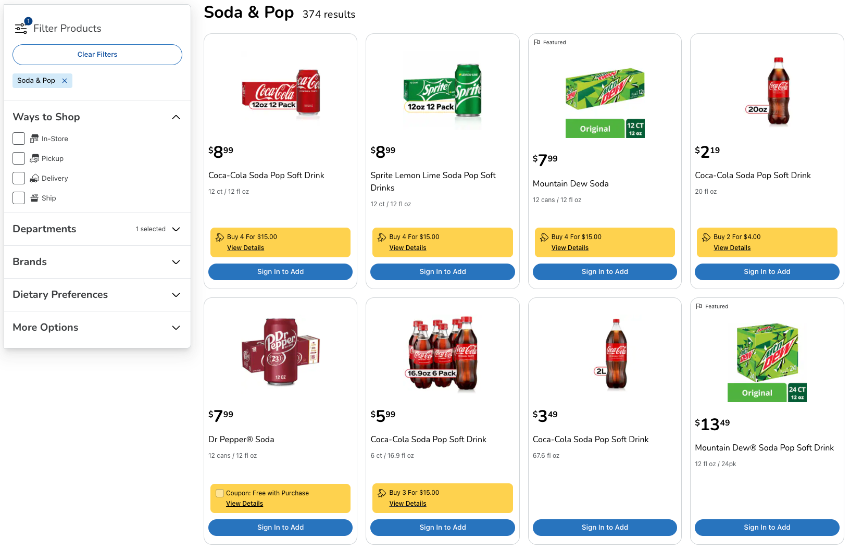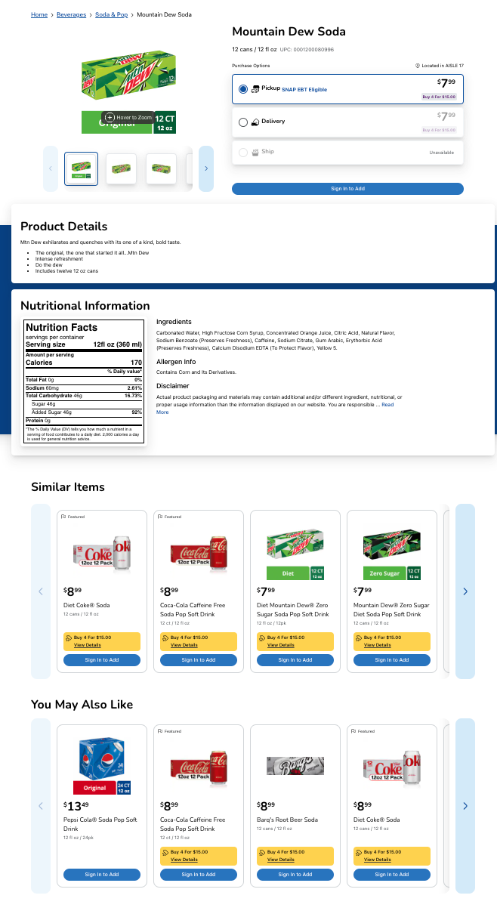

1. [**VeganEssentials**](https://veganessentials.com/)

**Description**

All of their products, free of animal testing and cruelty, are available here. The one-stop shop for all things vegan is called VeganEssentials.

**Advantages**

* Excellent website navigation makes it very simple to navigate the site, and the categories are simple to understand.
* The website's UI is pretty simple, but communicates the message and doesn't look boring.

**Disadvantages**

* The website only sells vegan products; there are none for other diets (e.g. gluten-free).
* The prices are high.

**Screenshots**



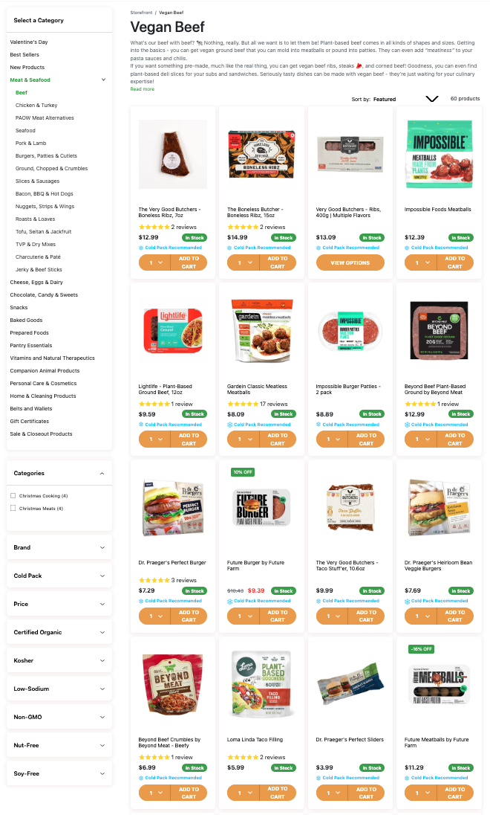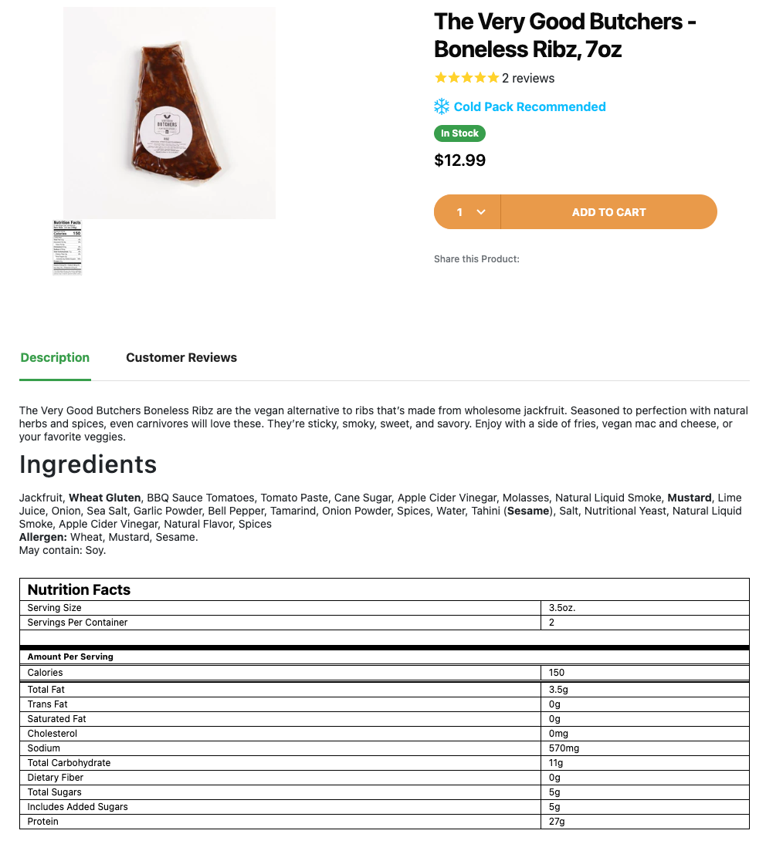

## Interviews

To determine what users would like the application to perform, two interviews were performed.

1. During the first interview, the user expressed interest in basic functionality, viewing all items as well as a particular item and adding items to their basket.
2. During the second interview, the user asked for basic functionality and more advanced features, such as searching for certain things and having a filter to find items that fit a particular diet.

## Requirements modelling

## Functional requirements

The following is a list of features the application should have:

1. Account creation and login page.
2. Users should be able to view the items and recipes (view all and a single item).
3. Admins can add, remove, and update products and recipes.
4. Depending on their diet, users can filter the items.
5. Items can be added to users' baskets.

## Non-functional requirements

1. To speed up the application, add Javascript validation (as well as PHP).
2. UUIDs are added to the URLs, so the user isn't aware of the database.

## Use Case Diagrams

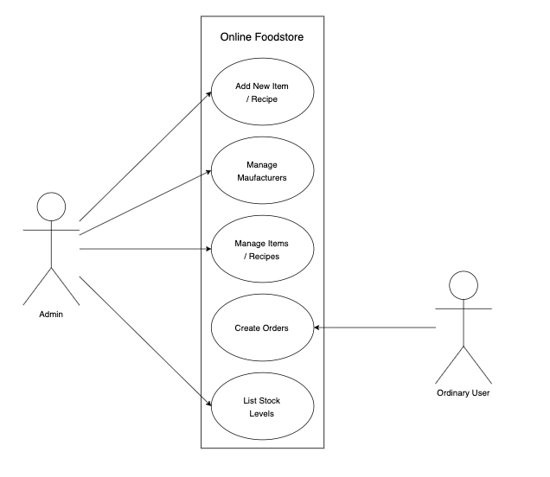

## Feasibility

The following technologies will be used for this application: Docker, Table Plus (for the database), and Laravel (Framework and Breeze).

There shouldn't be any compatibility issues with these technologies based on my previous experience using them together.

# Web Application Design

## Layout

## Interaction

## Colour schemes

## Font choices

## Wireframes

# Database Design

## Description

## Business Reporting Requirements

## Textual Representation of Dataset

## Business Rules

## Entity Relationship Diagram

## Tables

## Database Dictionary

# System Design/ Architecture Overview

## Introduction

## Model View Controller

## User Authentication

## Routing

## Templating

# Testing

* 1. Introduction
  2. Functional Testing

## Login/Registration

## Navigation

## Calculation

## CRUD

## Discussion of Functional Testing Results

* 1. User Testing
  2. Conclusion

# Project Management

## Introduction

## Project Phases

## Requirements

## Design

## Implementation

## Testing

## SCRUM Methodology (optional)

## Project Management Tools

## GitHub Project

## GitHub

# Reflection

## Your views on project

## How could the project be developed further?

## Assessment of your learning.

## Completing a large software development project

## Technical skills

## Further competencies and skills

# References